**Watari**

COUNSELLING & SUPPORT SERVICES SOCIETY

VANCOUVER, CANADA

Watari’s goal is to facilitate positive change in their community through youth, adult and community programs. As part of a student team, I helped to redesign their website.

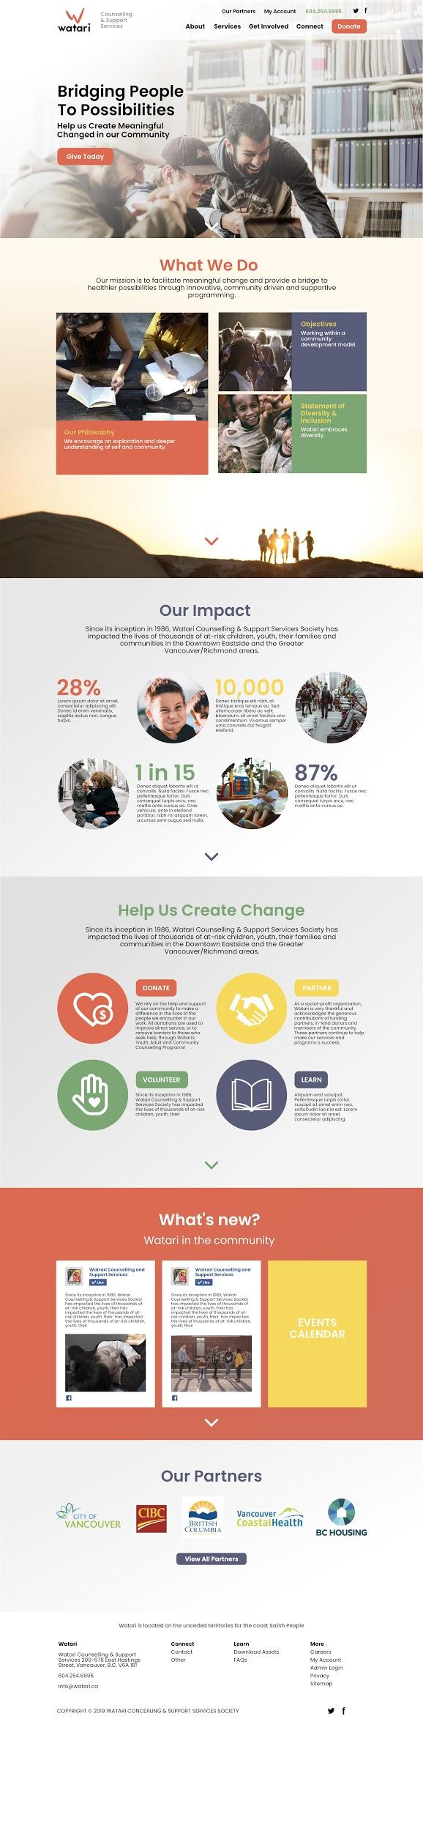

REDESIGN

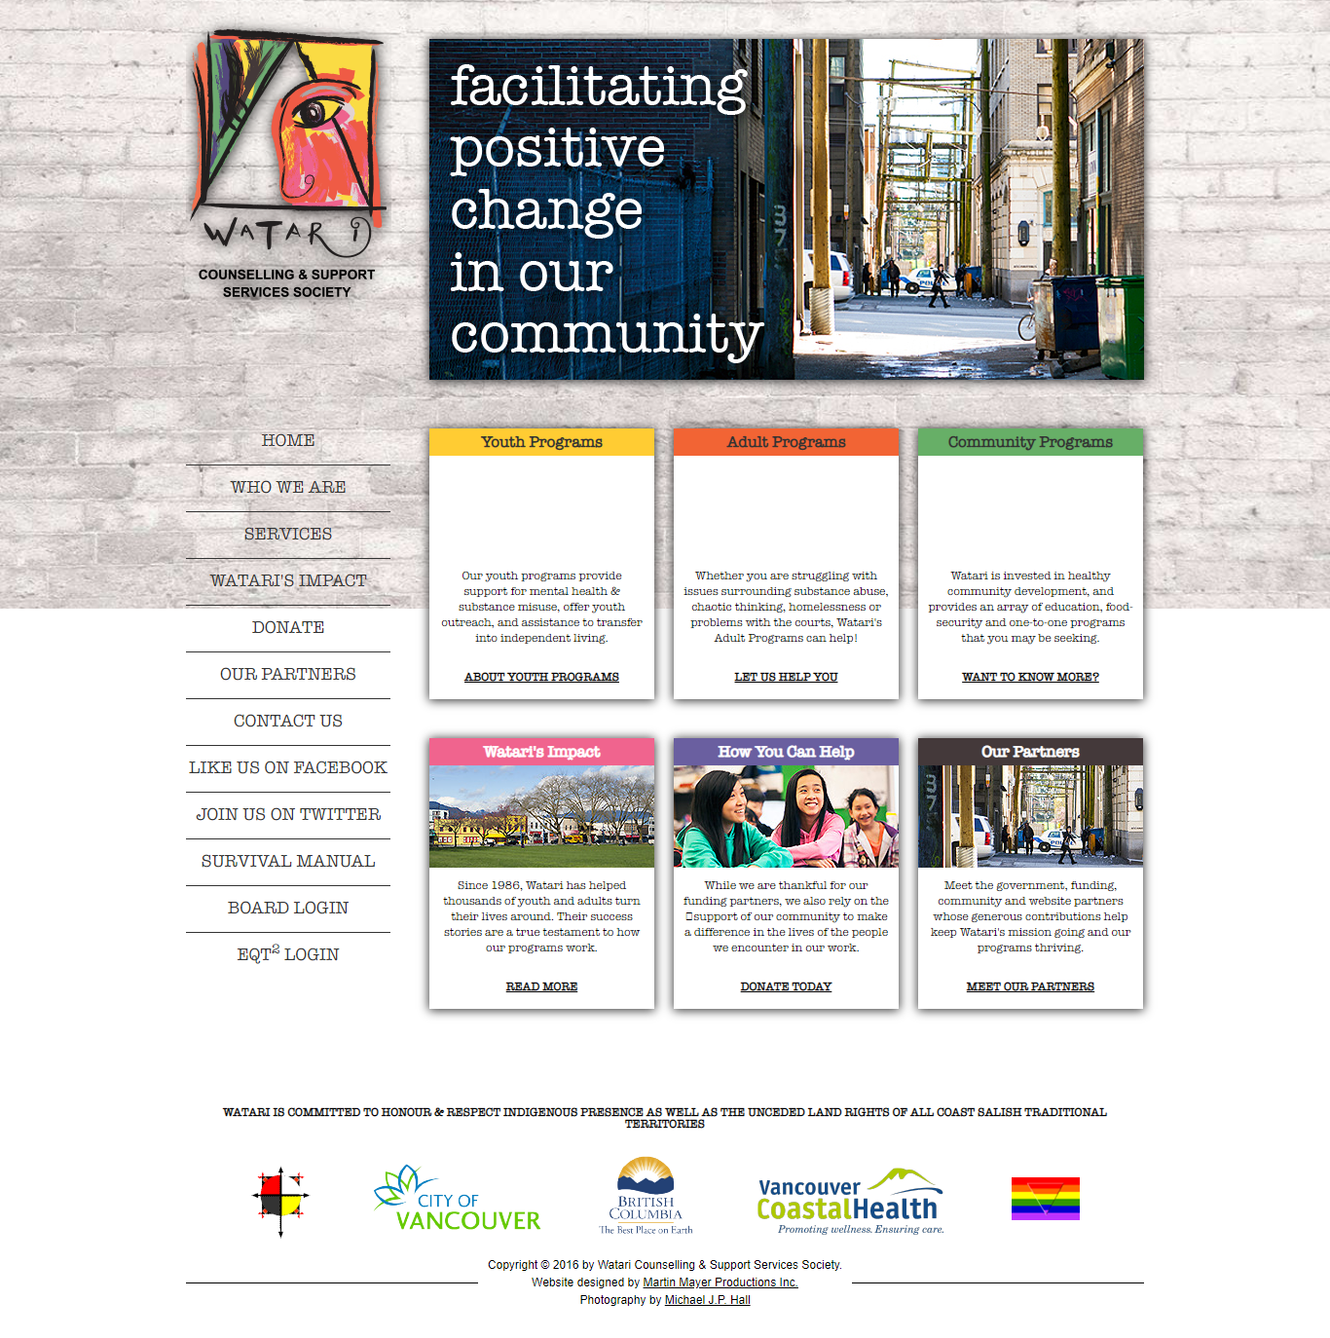

ORIGINAL WEBSITE

DESIGN CHALLENGES

1. The site was built before mobile-friendly was a thing
2. Updating content, such as adding new employee profiles to an “Our Team” page, was hard for Watari staff to accomplish
3. Content was displayed in blocks of text will little to no images
4. Call to actions, such as “Donate” and social media links were mixed in with nav links
5. Some background color vs text color contrast combos made it hard to read certain elements

GROUNDWORK

One of my responsibilities for this project was defining KPI’s and researching Watari’s “competitors”.

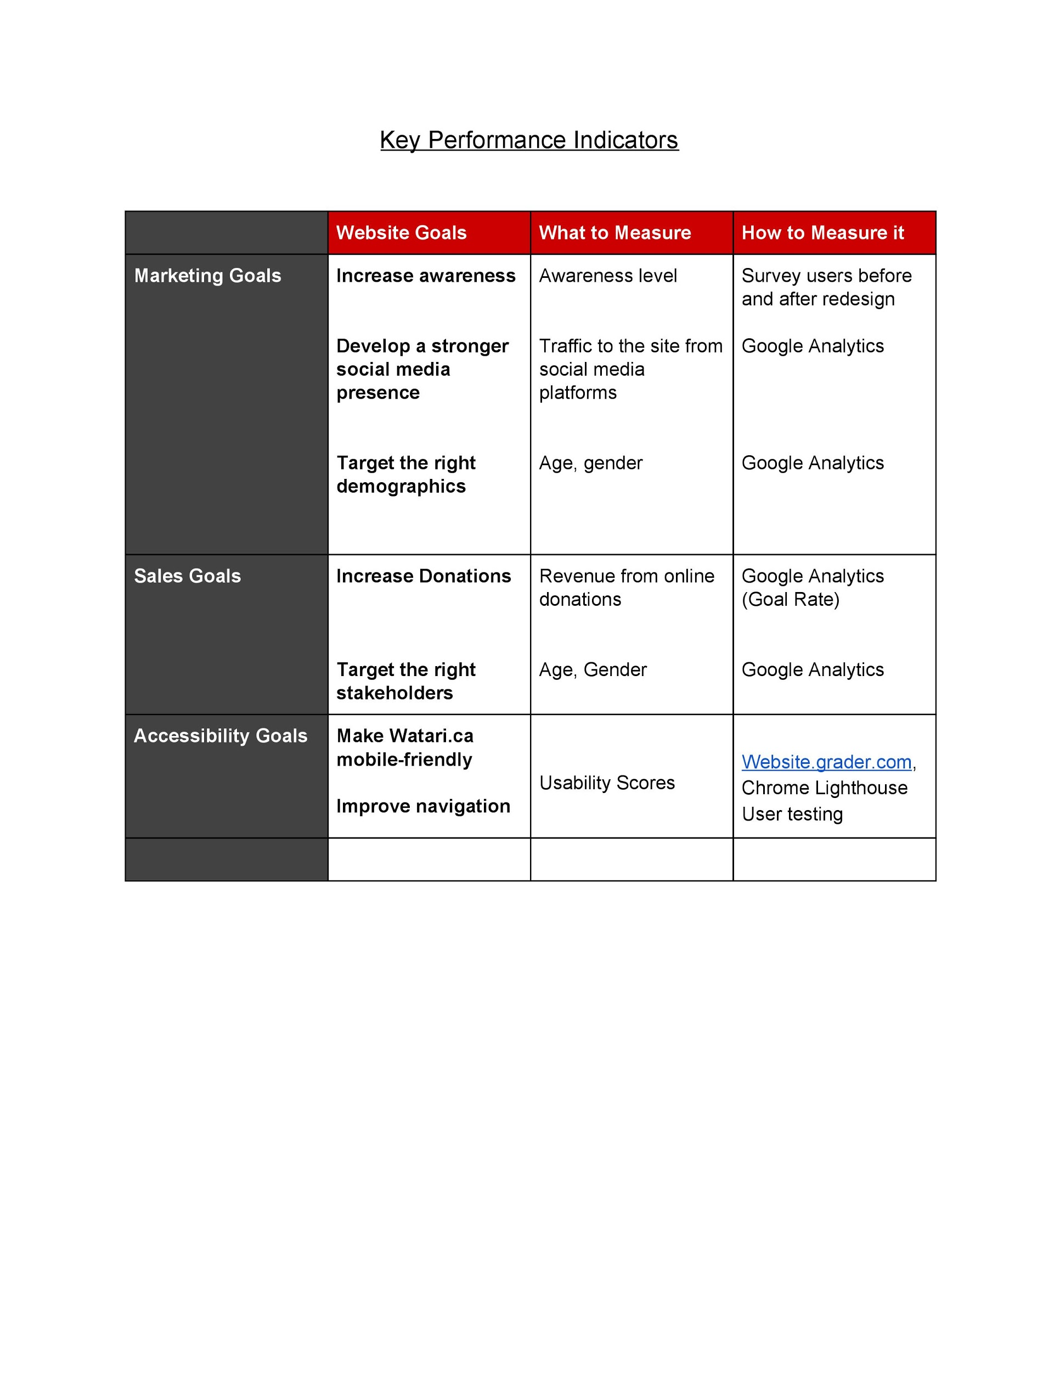

Once these KPI’s were established, I checked out other websites that were similar to Watari in the services they provided along with geographic location.

[Vancouver Coastal Health](http://www.vch.ca/)

[Counseling and Support Services of S.D&G.](http://css-sdg.ca/)

[Pacific Community Resource Society](https://pcrs.ca/)

[Battered Women’s Support Services](https://www.bwss.org)

The common strengths of these websites were: the use of social media icons, prominent search bar, clear navigation, simple color scheme, prominent use of call-to-actions, minimal text, use of a news feed.

To make my findings clear to my teammates, I outlined the positive attributes in green and negative attributes in red.

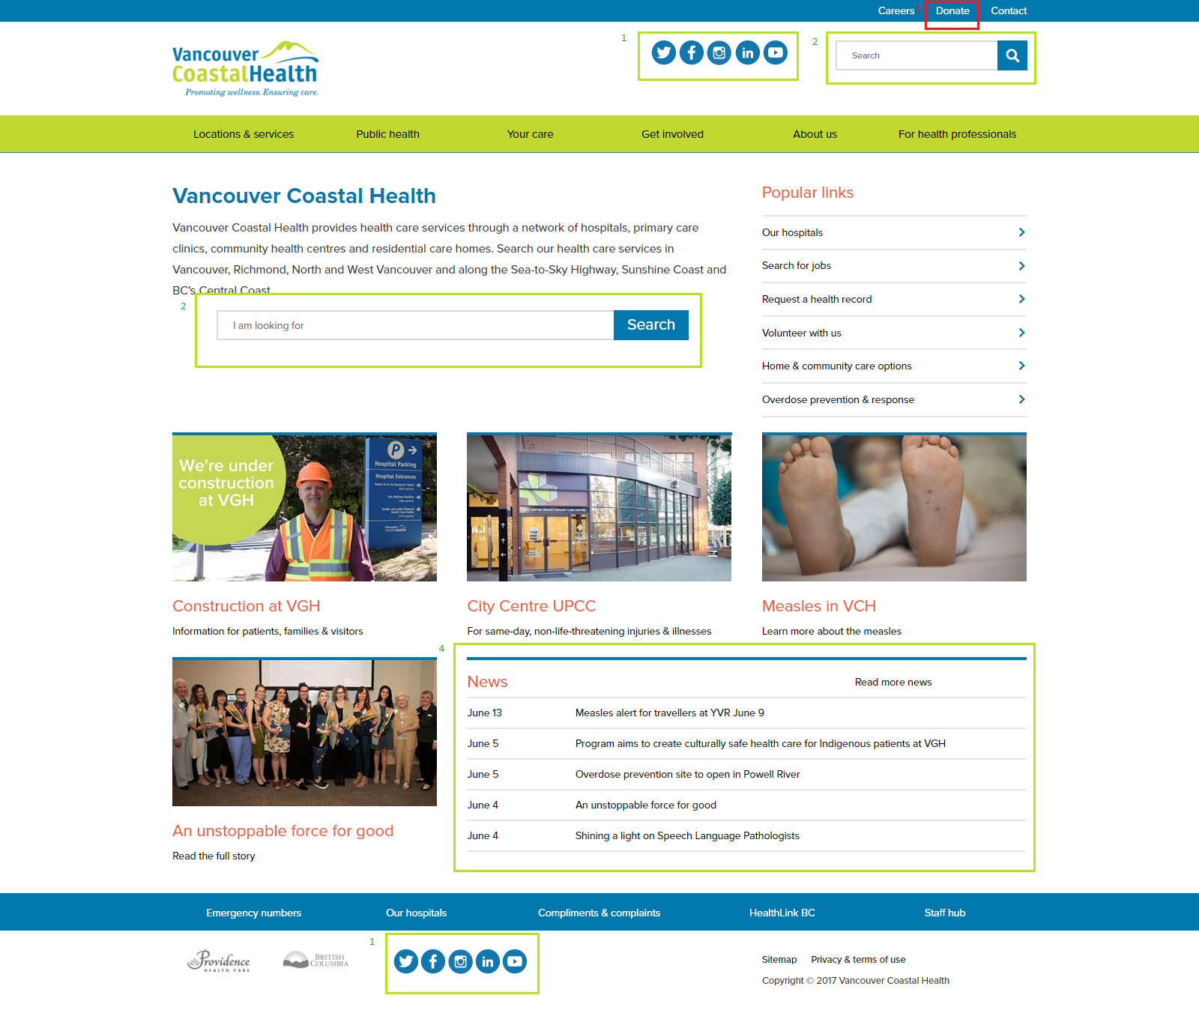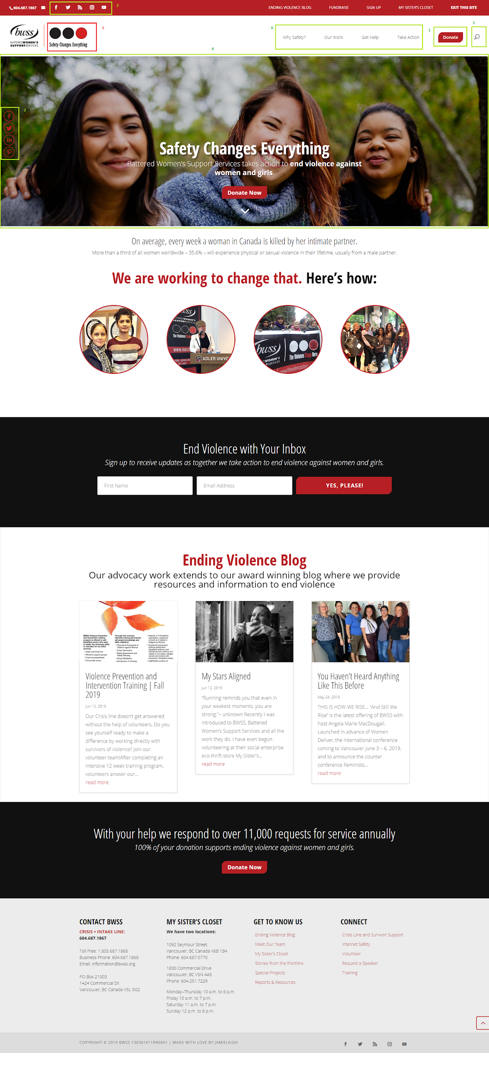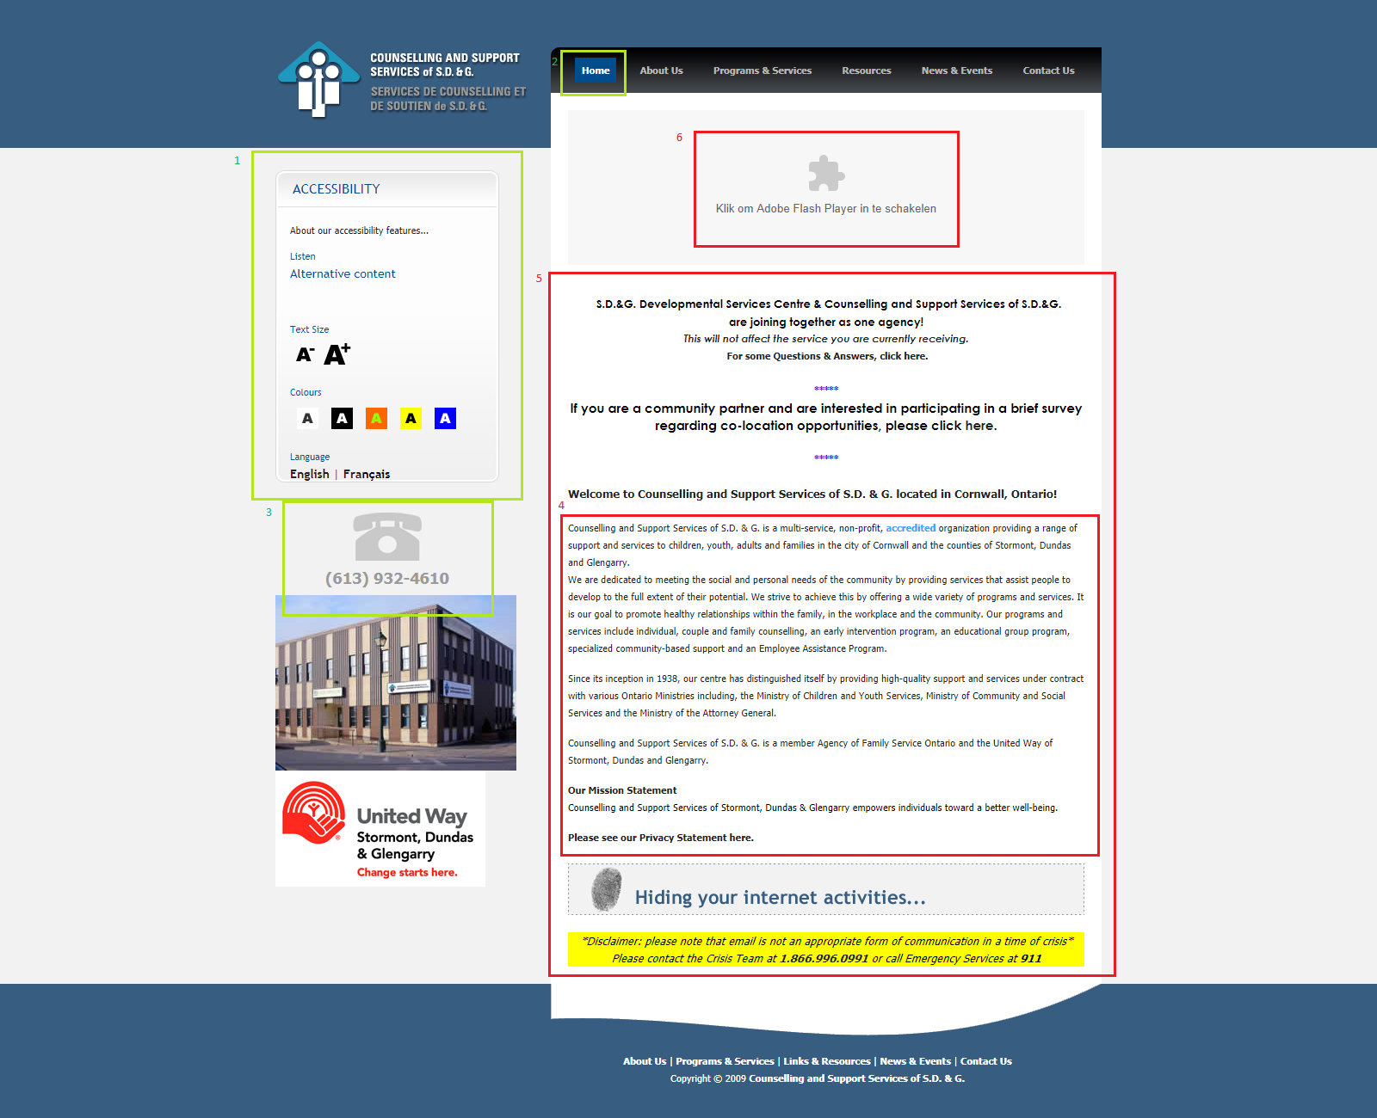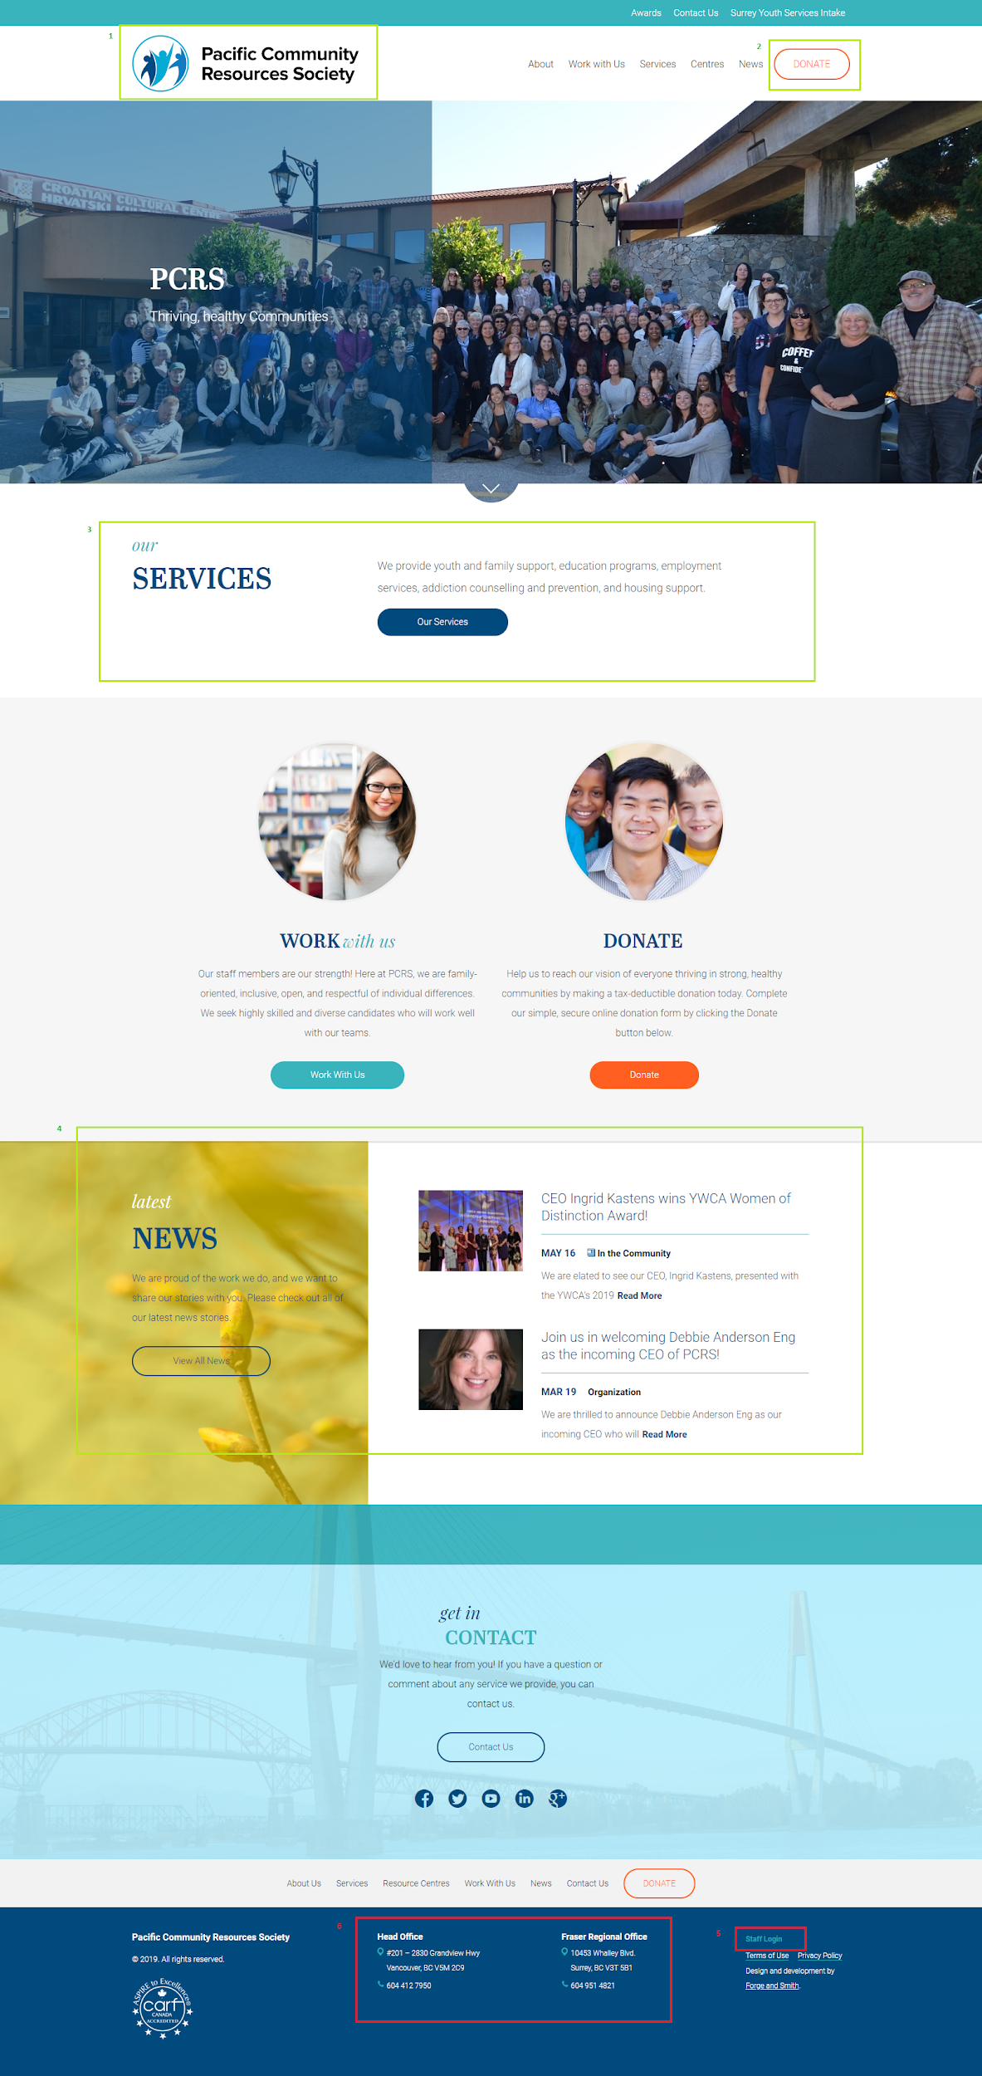

The overall goals for Watari’s website boiled down to:

1. Develop a better social media presence
2. Increase donations
3. Make the site accessible on mobile
4. Make the site more readable and accessible

SKETCHES

With these two Analyses in mind, my teammates developed primary wireframes.

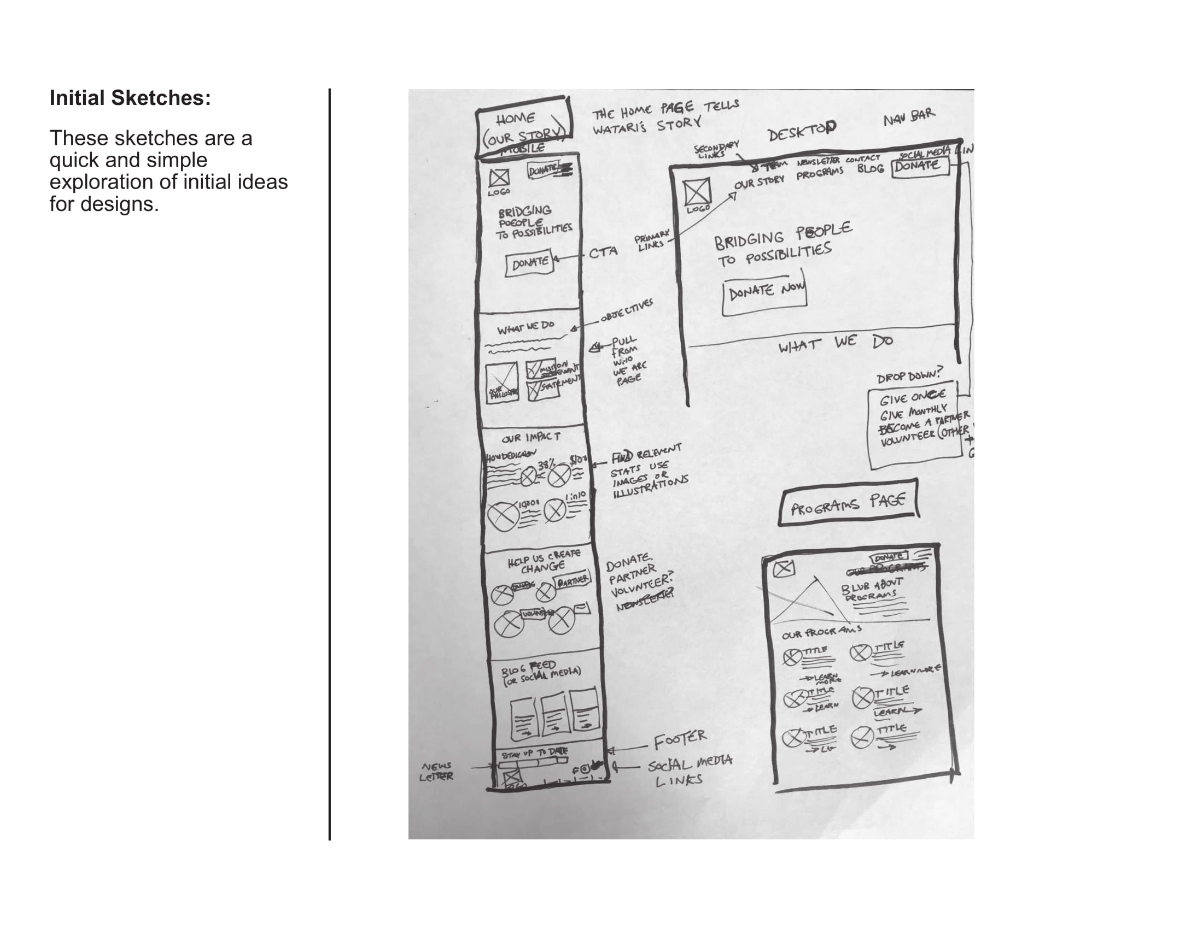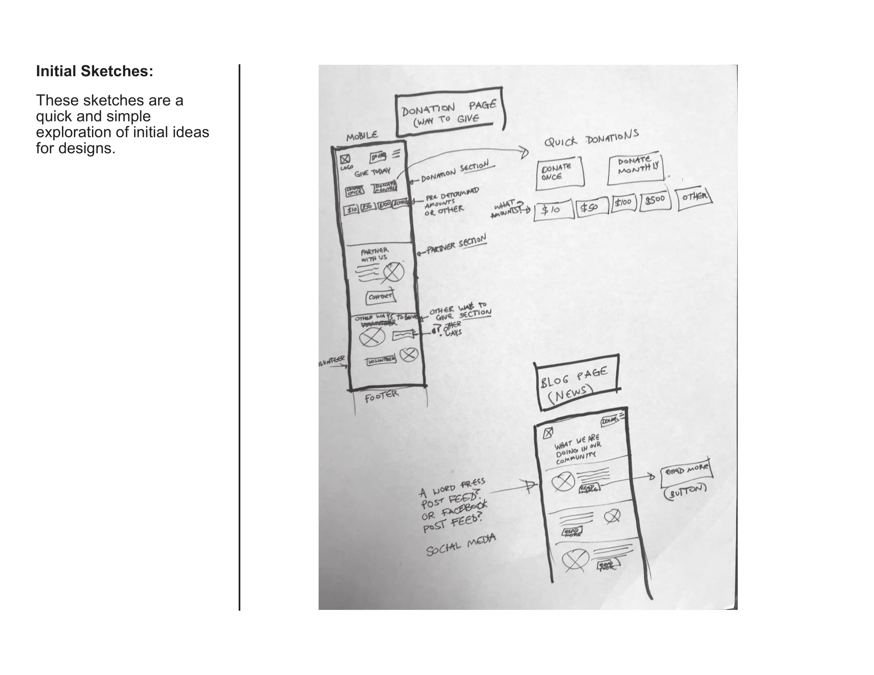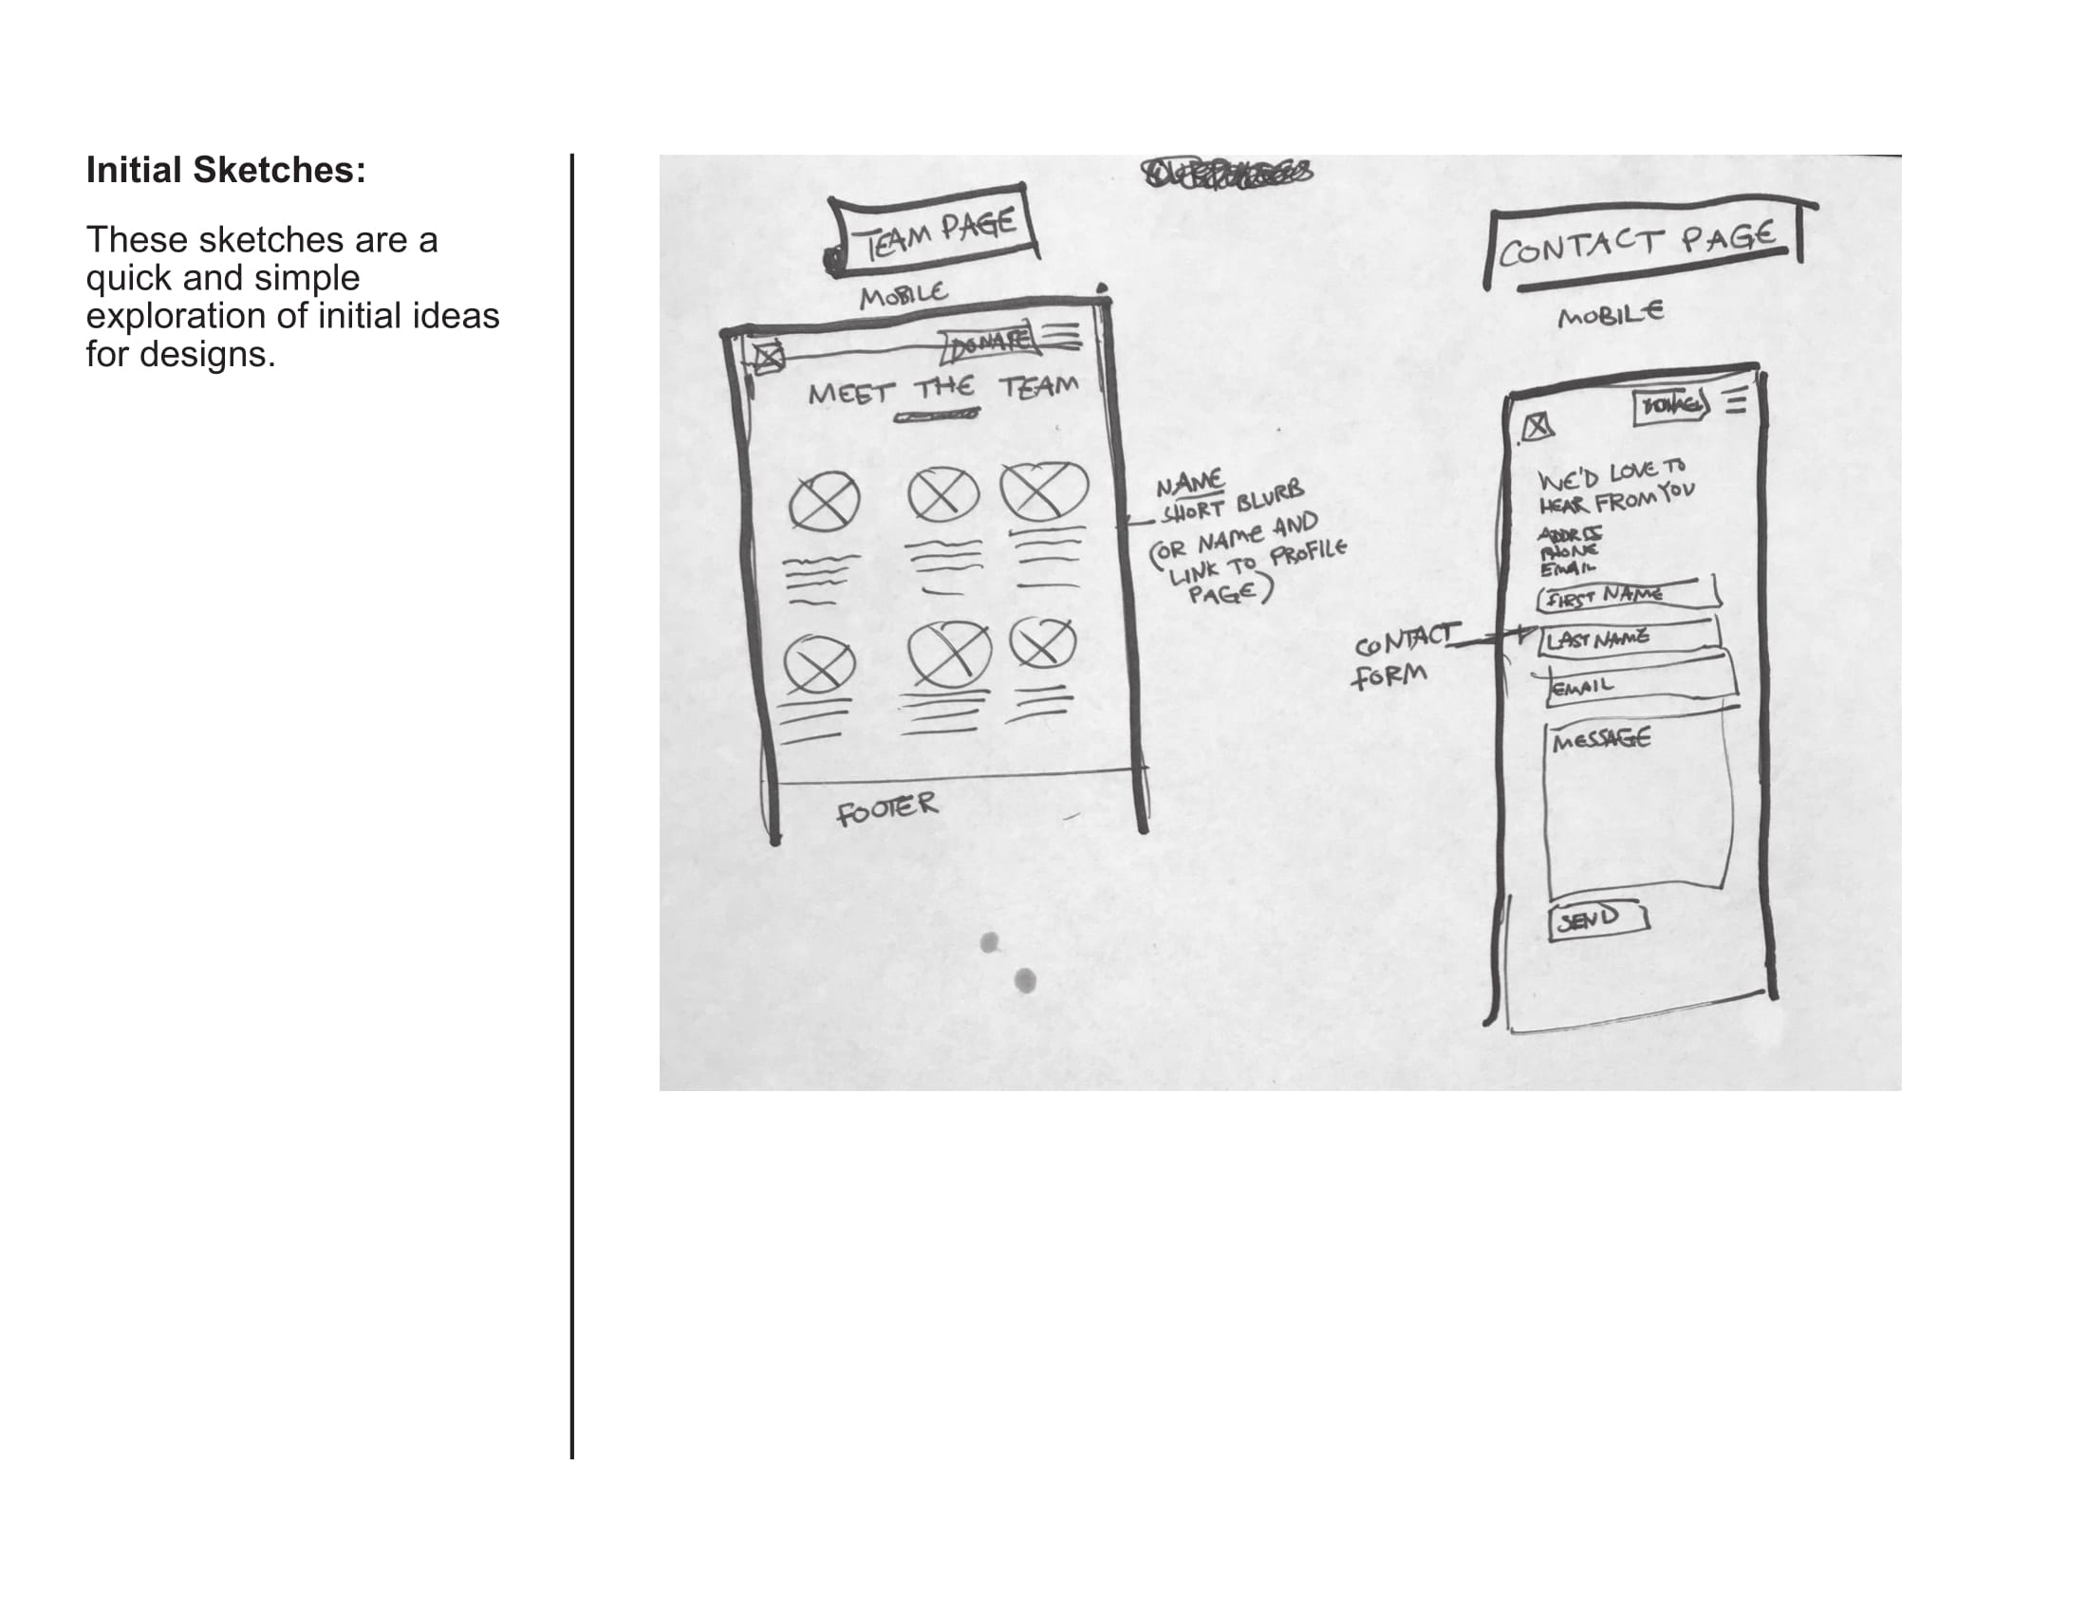

WIREFRAMES

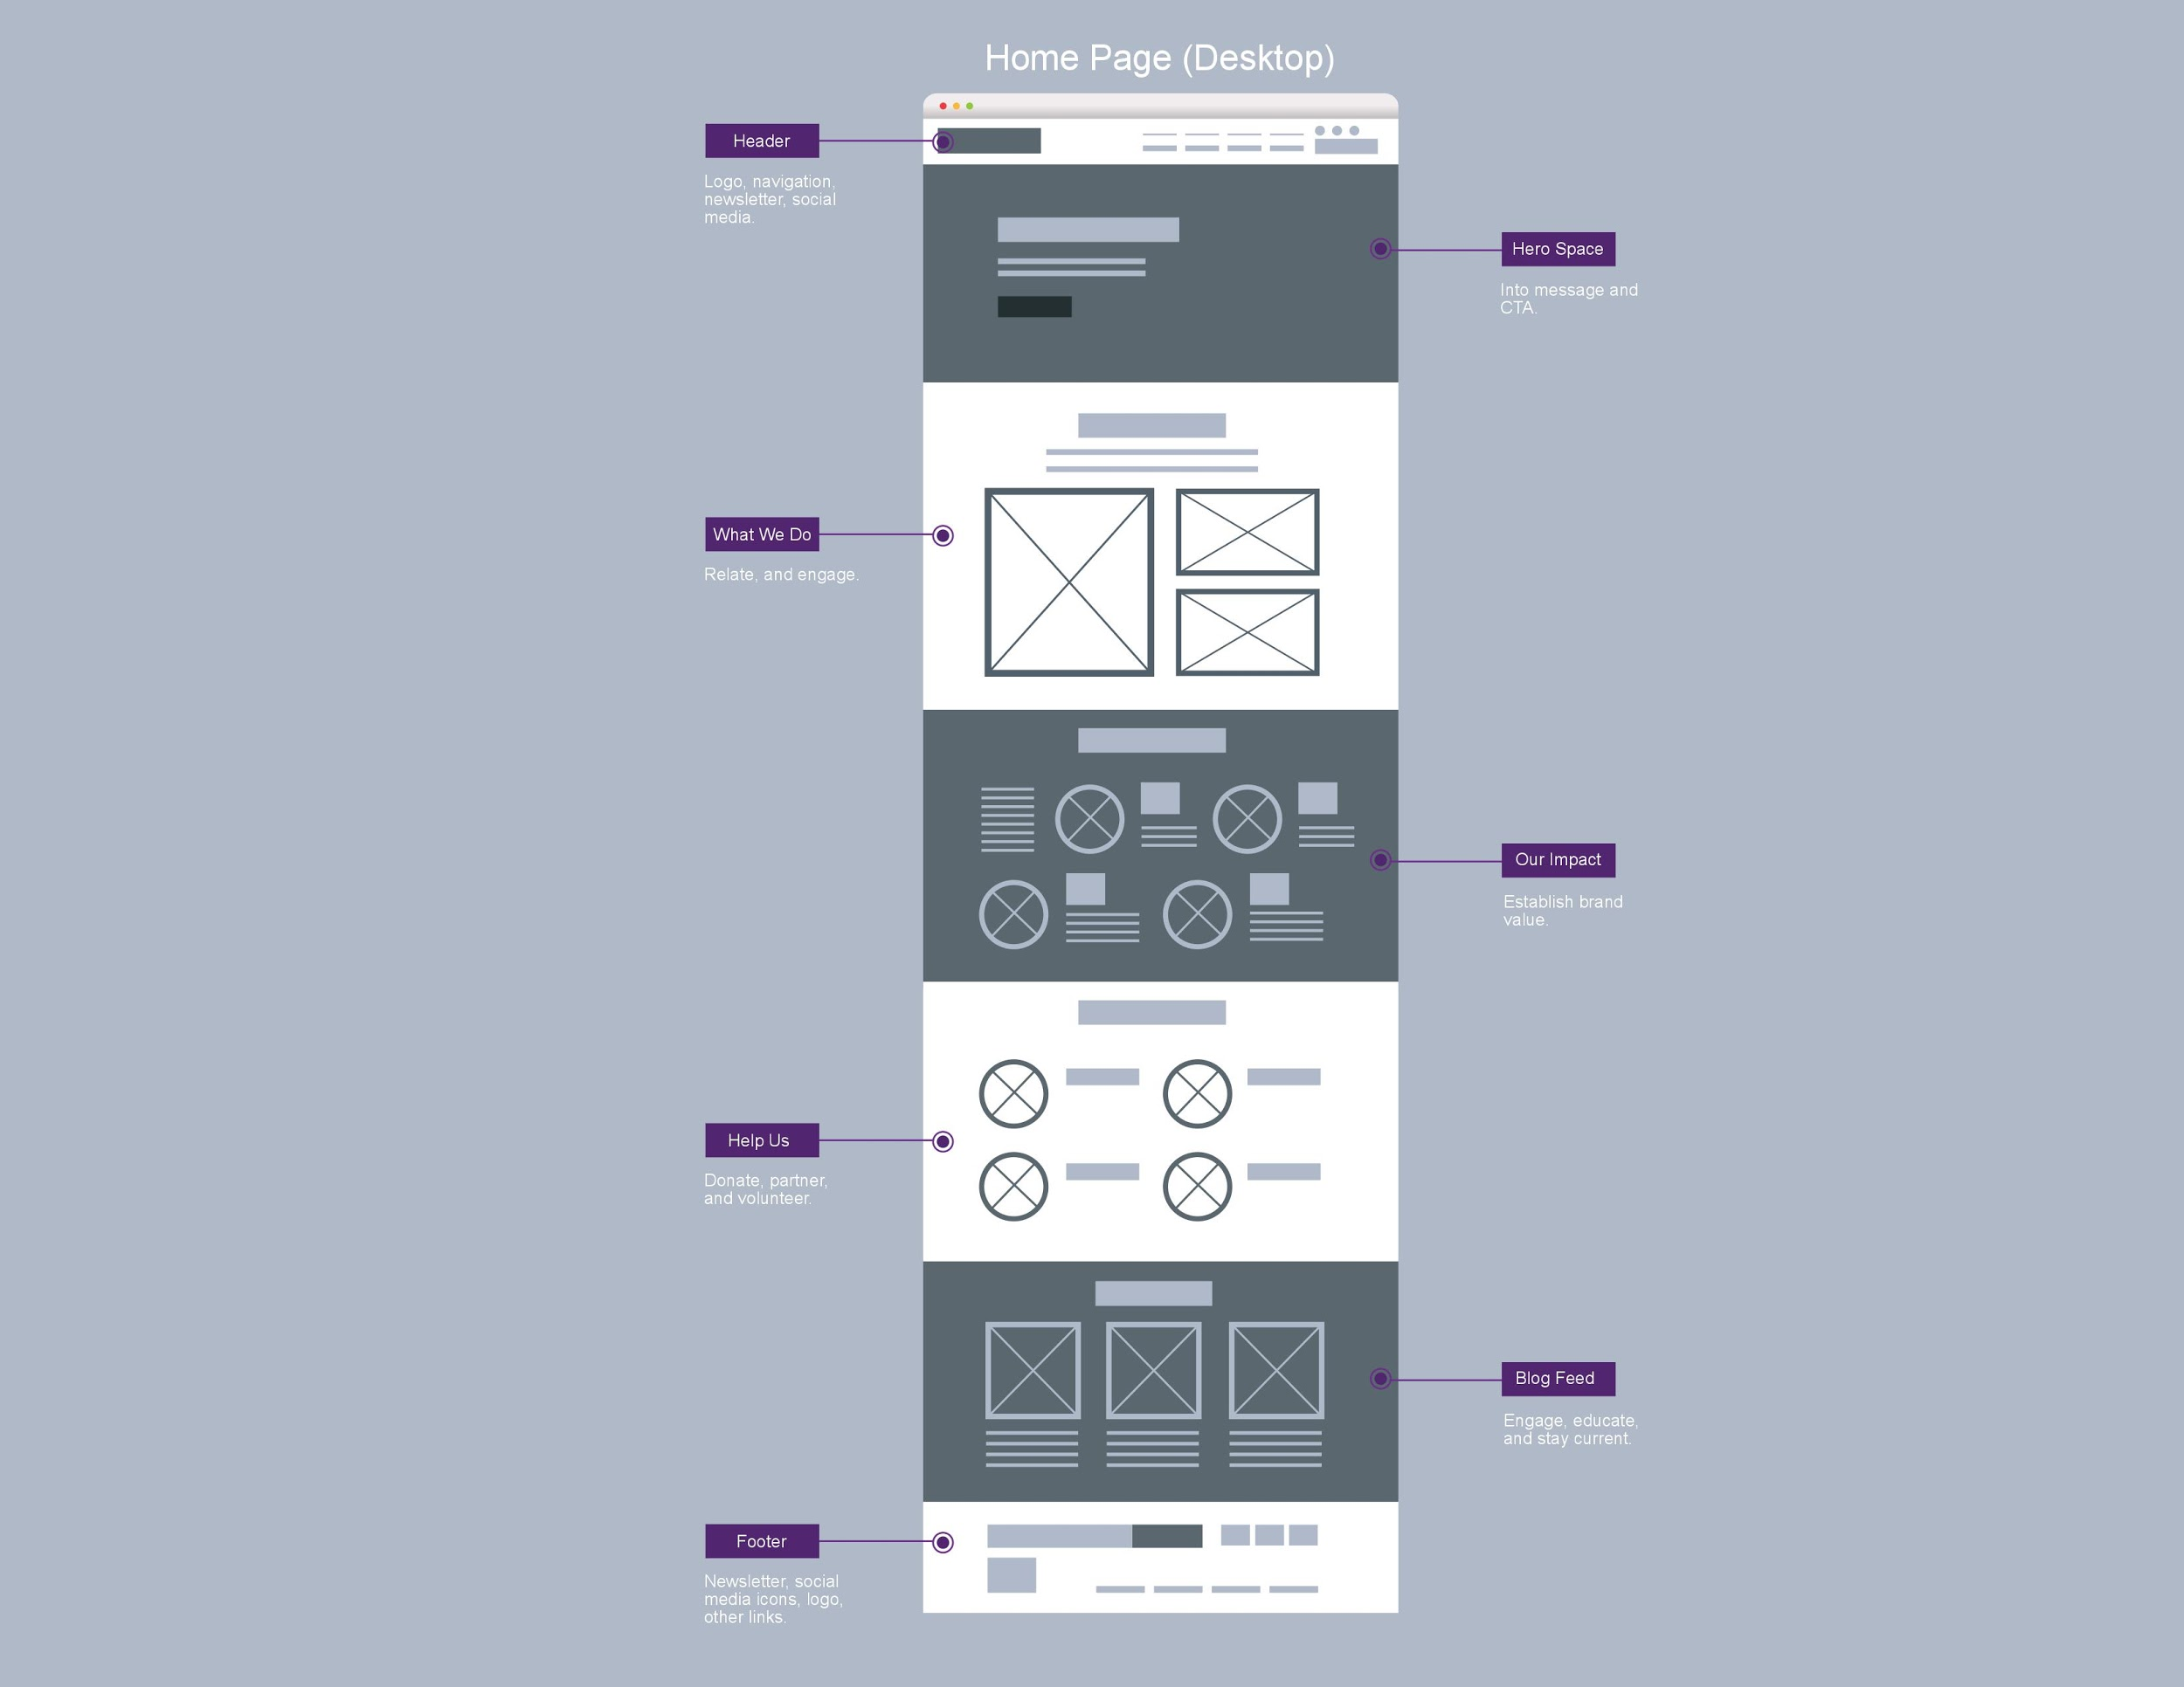

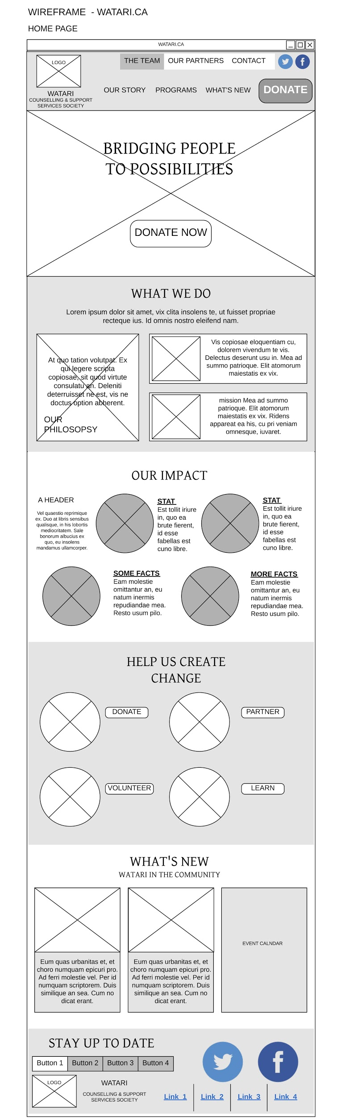

HIGH FIDELITY PROTOTYPE

